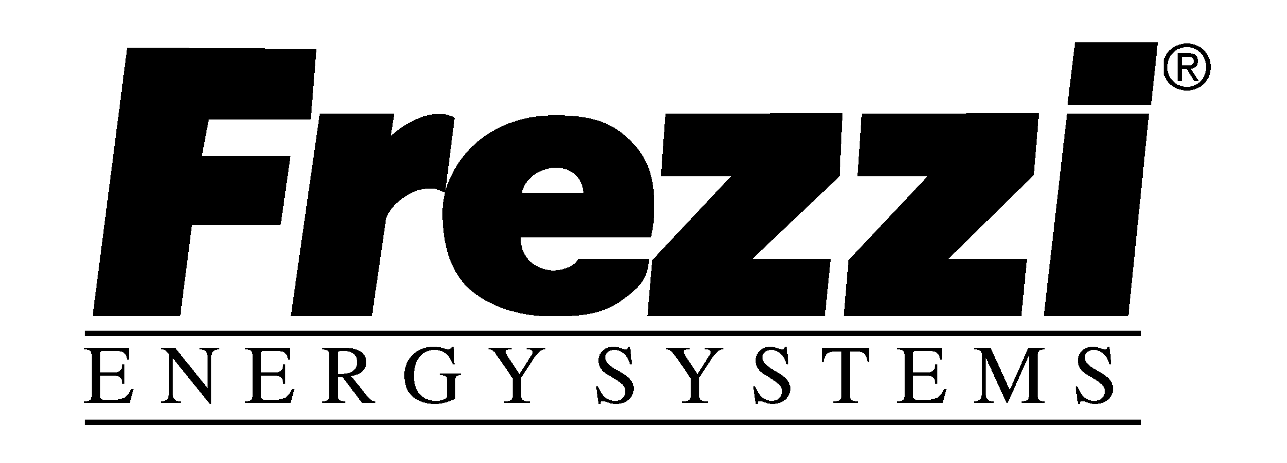 FOR IMMEDIATE RELEASE

Contact: Jim Crawford
Frezzi Energy Systems
Div of Frezzolini Electronics Inc.
7 Valley Street, Hawthorne, NJ 07506
Phone: 973-427-1160
Fax: 973-427-0934
http://www.frezzi.com
info@frezzi.com
Hawthorne, NJ – April 2, 2013 – for NAB2013

Frezzi SkyLight™– A New Advancement in Solid State Compact High Performance LED Broadcast Imaging Lighting at NAB 2013 Frezzi Booth C7936

High Intensity Daylight-Usable LED that Doesn't Fade in the Sun
Frezzi redefined high-output portable LED lighting with the revolutionary HyLight, now our advanced SkyLight delivers an impressive amount of daylight-balanced light suitable for indoor/outdoor news gathering and field production. It's a highly portable LED fixture powered by standard broadcast batteries, DC or AC power. Delivers equivalent light to a 650 Watt tungsten or 125W HMI source while drawing only 75W of power. Fully dimmable with selectable beam angles using quick change reflector technology.
● Ultra High Output – 240 fc at 5' in flood, 640 fc at 5' in spot – Highest output in power class
● Long Run Time – Over 1 Hour with Frezzi FLB-100 battery
● Small & Compact – Portable for “Run & Gun” in complete travel-friendly 2 head light kit
● High Quality White Light – High CRI single source 5600K daylight light without pixilation or color fringing

● True Color Dimming – 100% to 0 dimming without color shift

● Wide Range Input – 12 to 36 VDC, using A/B or V-Mnt. battery, 30V belts/power packs or AC power supply
● Weatherproof – Useable in all weather conditions
● Frezzi Durability – All aluminum design built to Frezzi “industry work horse” standard. 50,000hr LED life.
● Silent Operation – No fan with reliable passive cooling
● Complete Accessories – Barn doors, filters and light modifiers available

With this latest achievement in Lighting Technology for TV Field production all desired
aspects of portable lighting are achieved with a new benchmark in output and efficiency.

Powered by AC Mains or Standard Broadcast Snap-on or V-Mount camera batteries, the SkyLight™ High Output Solid State Light HD Chip-On Board LED source combines state of the art efficiency with the perfection of Frezzi's integrated electronic and mechanical award winning designs. The output is fully dimmable without color shift and features quick interchangeable reflectors for beam width selection.

Frezzi has manufactured portable lighting and power products for the news media industry, both film and video for over 70 years. Frezzi Energy Systems is a division of Frezzolini Electronics Inc. Contact Frezzi toll free at: 800.345.1030 and for more information visit our website at: www.frezzi.com to see all our latest innovations.

